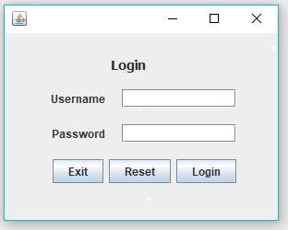

|  |  |
| --- | --- |
| ID | 1 |
| Test case name | Login |
| Objective | User login |
| Test scenario | 1. User enters username and password 2. Click login button |
| Input | 1. Username 2. Password |
| Expected output | User logged in successfully |
| -Actual output | User logged in successfully |
| Pass/Fail | Pass |

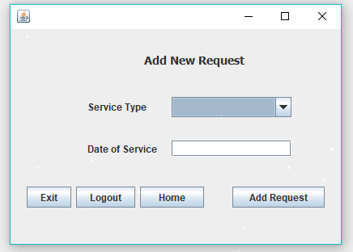

|  |  |
| --- | --- |
| ID | 2 |
| Test case name | Add New Request |
| Objective | The resident adds new request in the system by entering the service type and the date of the service. |
| Test scenario | 1. The resident selects the service from the service type list. 2. The resident enters the date of service 3. Click Add Request |
| Input | 1. Service type 2. Date of the service |
| Expected output | Request Added successfully |
| Actual output | Request Added successfully |
| Pass/Fail | Pass |

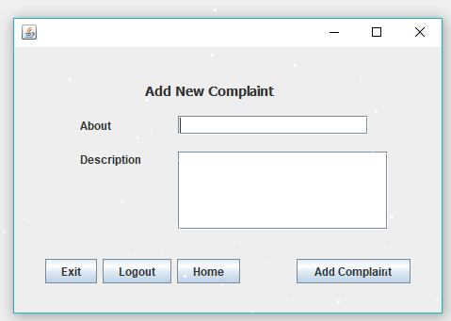

|  |  |
| --- | --- |
| ID | 3 |
| Test case name | Add New Complaint |
| Objective | The resident adds a complaint in the system that is not satisfied him. |
| Test scenario | 1. The resident enters briefly about the complaint 2. The resident writes a description about the complaint 3. Click Add Complaint |
| Input | 1. the type of complaint 2. Description |
| Expected output | Complaint Added successfully |
| Actual output | Complaint Added successfully |
| Pass/Fail | Pass |

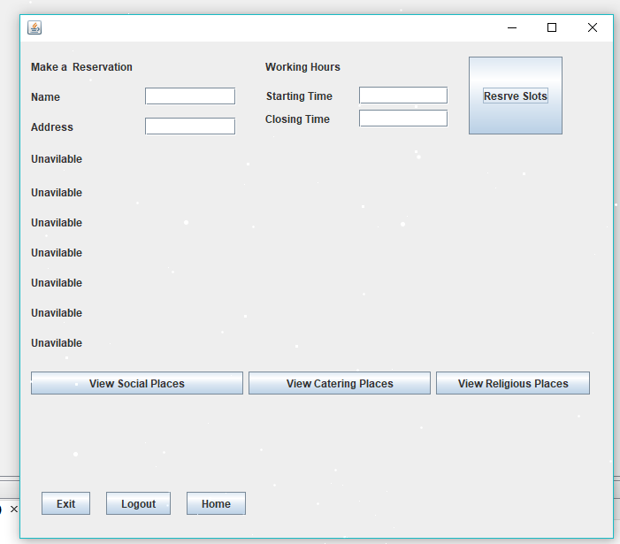

8

|  |  |
| --- | --- |
| ID | 4 |
| Test case name | Make a Reservation |
| Objective | The resident makes a reservation in the system |
| Test scenario | 1. The resident makes a reservation by entering the type of the place from the three views buttons 2. The available time slots appear 3. The resident enters the name, address, starting time and closing time of the place 4. Click Reserve slot |
| Input | 1. Click one of the view buttons (places buttons) 2. Name and address 3. Start time and end time |
| Expected output | Place Reserved successfully |
| Actual output | Place Reserved successfully |
| Pass/Fail | Pass |

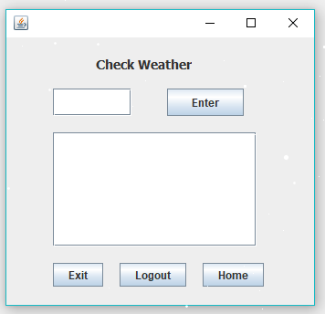

|  |  |
| --- | --- |
| ID | 5 |
| Test case name | Check Weather |
| Objective | The resident Check the weather of any city in the system |
| Test scenario | 1. The resident enters the name of the city 2. The weather appears |
| Input | 1. Name of the city |
| Expected output | The weather appears |
| Actual output | The weather appears |
| Pass/Fail | Pass |

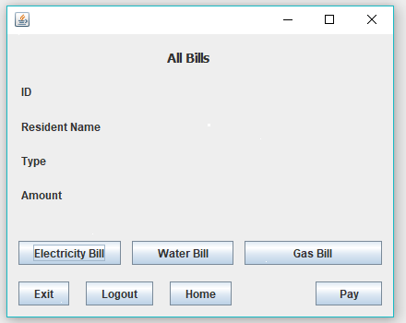

|  |  |
| --- | --- |
| ID | 6 |
| Test case name | View All Bills |
| Objective | The resident View His Bills in the system |
| Test scenario | 1.The resident Chooses to view the bill by clicking on the buttons of bills  2. The information of the bill appears |
| Input | 1. Clicking the button of bill type |
| Expected output | Bill information appears |
| Actual output | Bill information appears |
| Pass/Fail | Pass |

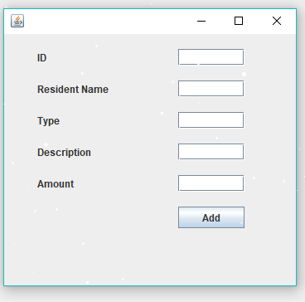

|  |  |
| --- | --- |
| ID | 7 |
| Test case name | Add New Bills |
| Objective | The Resident Service Employee adds the bills of the Residents in the system |
| Test scenario | 1.The resident Service employee enters the id, resident name, type, description and the amount of Bill |
| Input | 1. ID 2. Resident name 3. Type 4. Description 5. Amount |
| Expected output | Bill inserted |
| Actual output | Bill inserted |
| Pass/Fail | Pass |

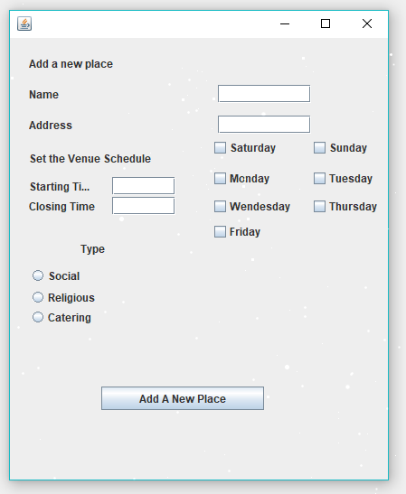

|  |  |
| --- | --- |
| ID | 8 |
| Test case name | Add a New Place |
| Objective | The Resident Service Employee adds the bills of the Residents in the system |
| Test scenario | 1. The resident Service employee enters the name, address, starting and closing time 2. The resident Service employee selects the available days and the type of the place |
| Input | 1. Name 2. Address 3. Starting time 4. Closing time 5. Available days 6. Type of place |
| Expected output | Place Added Successfully |
| Actual output | Place Added Successfully |
| Pass/Fail | Pass |

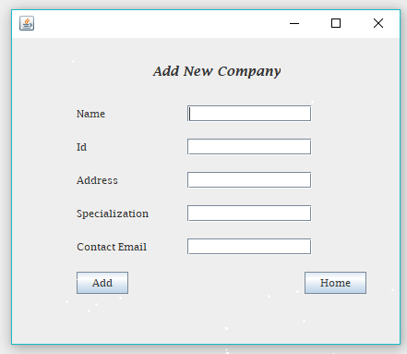

|  |  |
| --- | --- |
| ID | 9 |
| Test case name | Add New Company |
| Objective | The PR employee adds new company in the system |
| Test scenario | 1.The PR employee enters the name, id, address, specialization and the email of company |
| Input | 1. Name 2. ID 3. Address 4. specialization 5. E-mail |
| Expected output | Company Added Successfully |
| Actual output | Company Added Successfully |
| Pass/Fail | Pass |

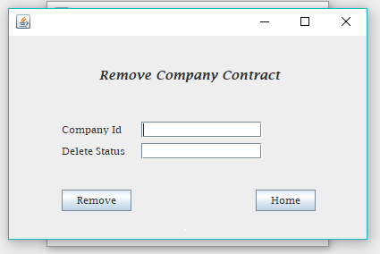

|  |  |
| --- | --- |
| ID | 10 |
| Test case name | Remove Company Contract |
| Objective | The PR employee removes company contract in the system |
| Test scenario | 1.The PR employee enters the company id and the delete status |
| Input | 1. Company id 2. Delete status |
| Expected output | Contract Removed Successfully |
| Actual output | Contract Removed Successfully |
| Pass/Fail | Pass |